Creating an Image from a Snapshot in Azure
SOP



Table of Contents

1. Creating an Image from a Snapshot in Azure 3
1.1 Description 3
1.2 Architecture Diagram 3
1.3 Lab Steps 4
1.4 Troubleshooting 5
1.5 Supporting References 5

1. Creating an Image from a Snapshot in Azure

1.1 Description
Creating an image is an important aspect when deploying vast applications on cloud. There are many ways to take an image from an existing VM. One such method is to take an image from snapshot. This involves executing Powershell commands to achieve the task as there is no direct approach in Portal.

1.2 Architecture Diagram
The diagram below displays a visual representation of the application architecture:

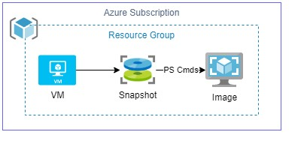

1.3 Lab Steps
Follow the steps outlined below to achieve the objective of this lab exercise:

- Create a VM.
- Create a Snapshot:
  - Subscription: Microsoft Azure Enterprise
  - Resource Group: <Dept>-<EmpID>-RG
  - Name: <some name>
  - Region: Central US (Example)
  - Snapshot Type: Full
  - Source Disk: <Select the disk that was created when creating VM>
  - Source Type: Standard HDD
  - Click on Create.
- Open the Cloud Shell (located adjacent to search bar on the top).
- When asked for Create a Storage account, do the following:
  - Select Advanced Options
  - Region: Central US (Example)
  - Storage Account Name: <Some unique name>
  - File Share Name: <Some unique name>
  - Click on Create.
- Select Powershell once the shell is opened.

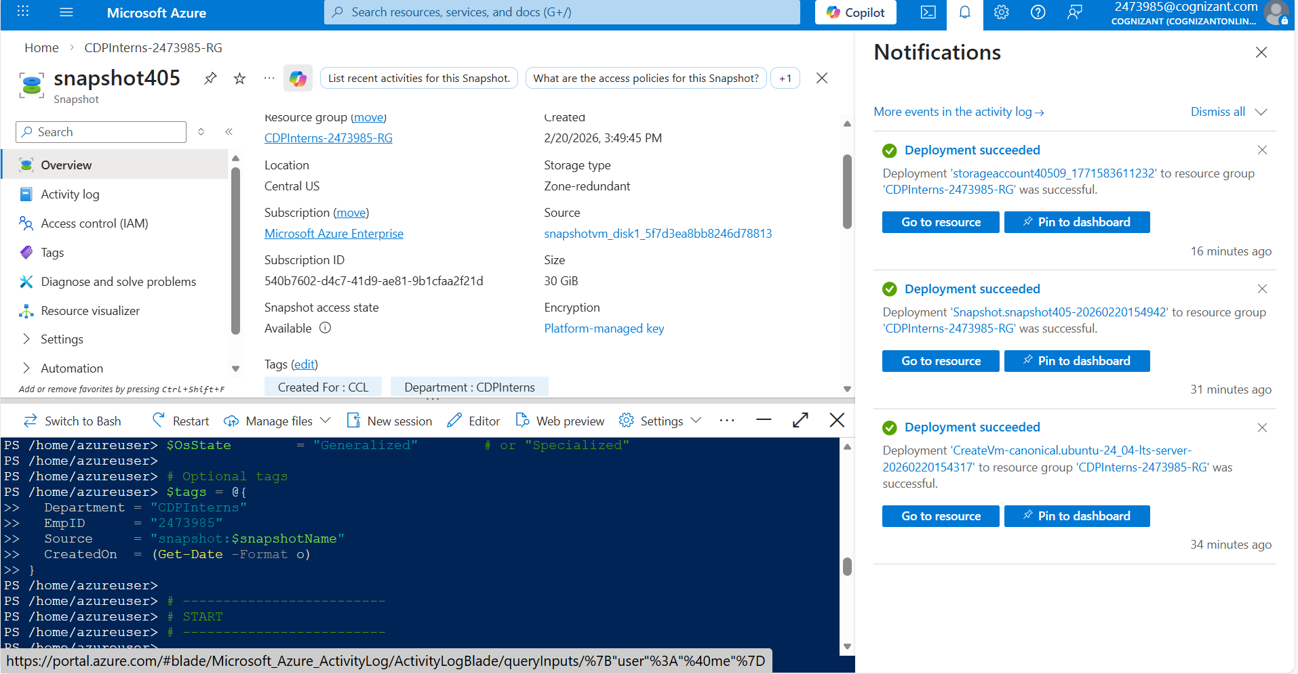

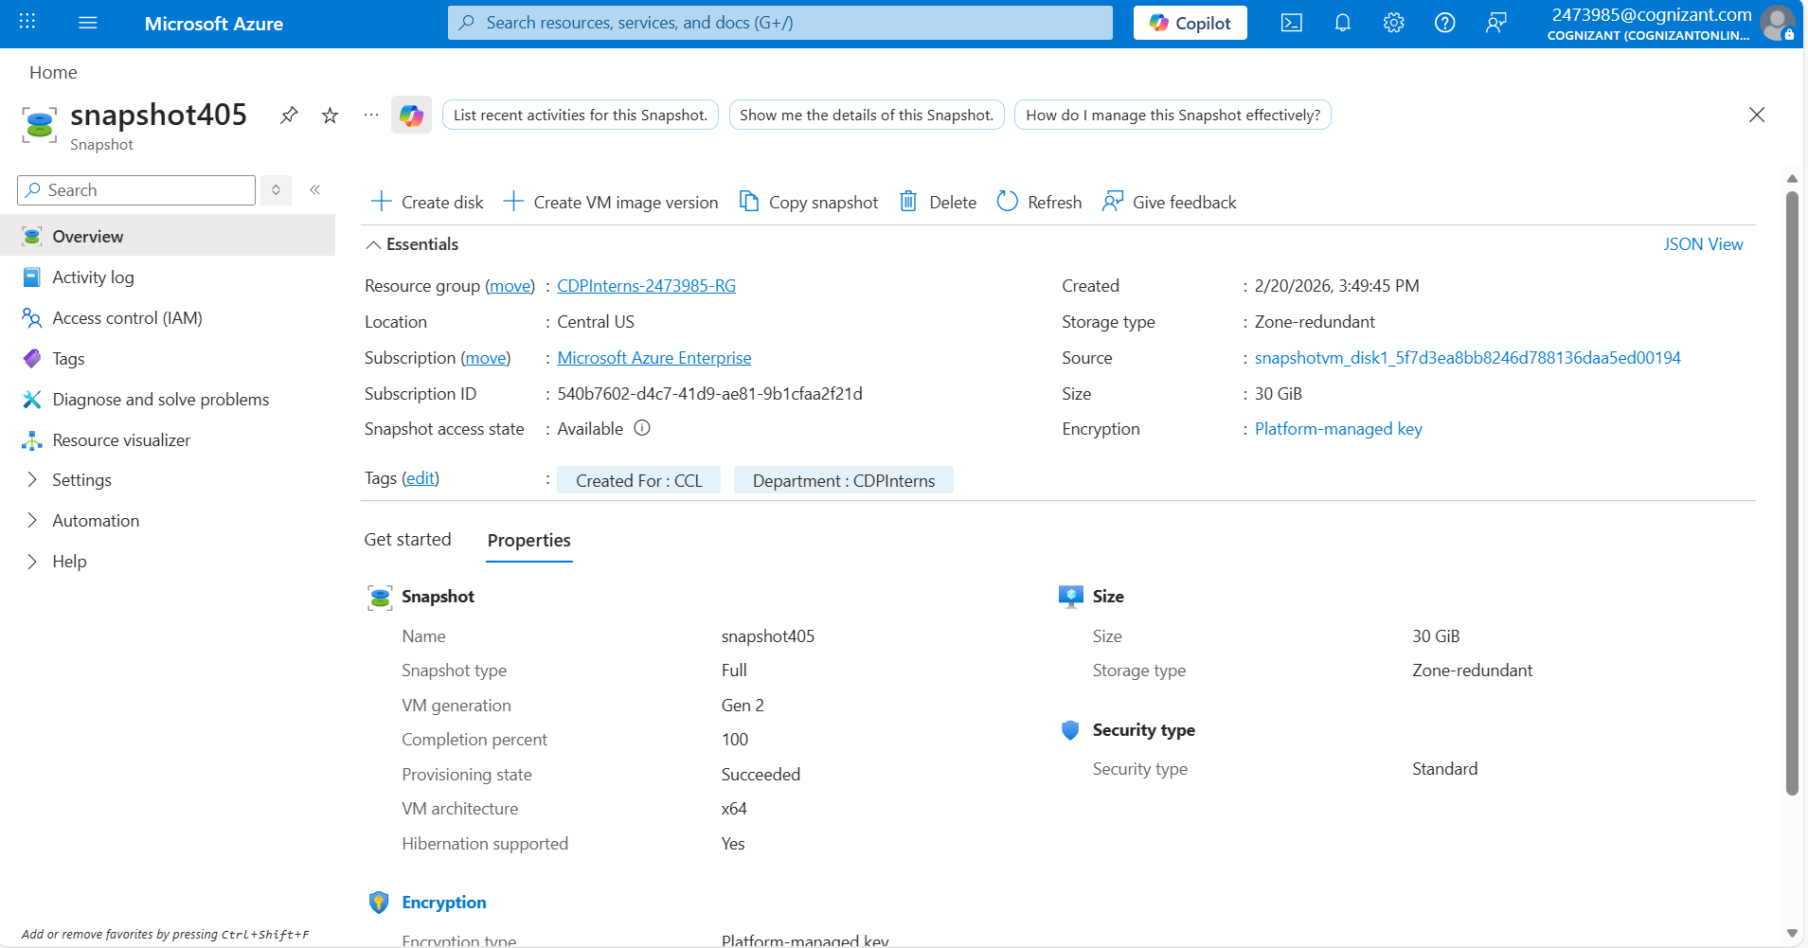

- Enter the following commands one by one:
$rgName = "<Dept>-<EmpID>-RG"
$location = "<location of RG>" $snapshotName = "<name of the snapshot>"
$imageName = "<Some unique name>"
- Once the above commands are executed, execute the following one by one:
$snapshot = Get-AzSnapshot -ResourceGroupName $rgName SnapshotName $snapshotName

$imageConfig = New-AzImageConfig -Location $location
$imageConfig = Set-AzImageOsDisk -Image $imageConfig -OsState Generalized -OsType Windows -SnapshotId $snapshot.Id

New-AzImage -ImageName $imageName -ResourceGroupName $rgName -
Image $imageConfig
- After executing the commands, a JSON output will be presented in the shell.
- Navigate to Images service page to see the newly created image.
- Click on the image and select create VM. This will create a new VM with the contents of the snapshot.

1.4 Troubleshooting
S. No | Problem | Solution
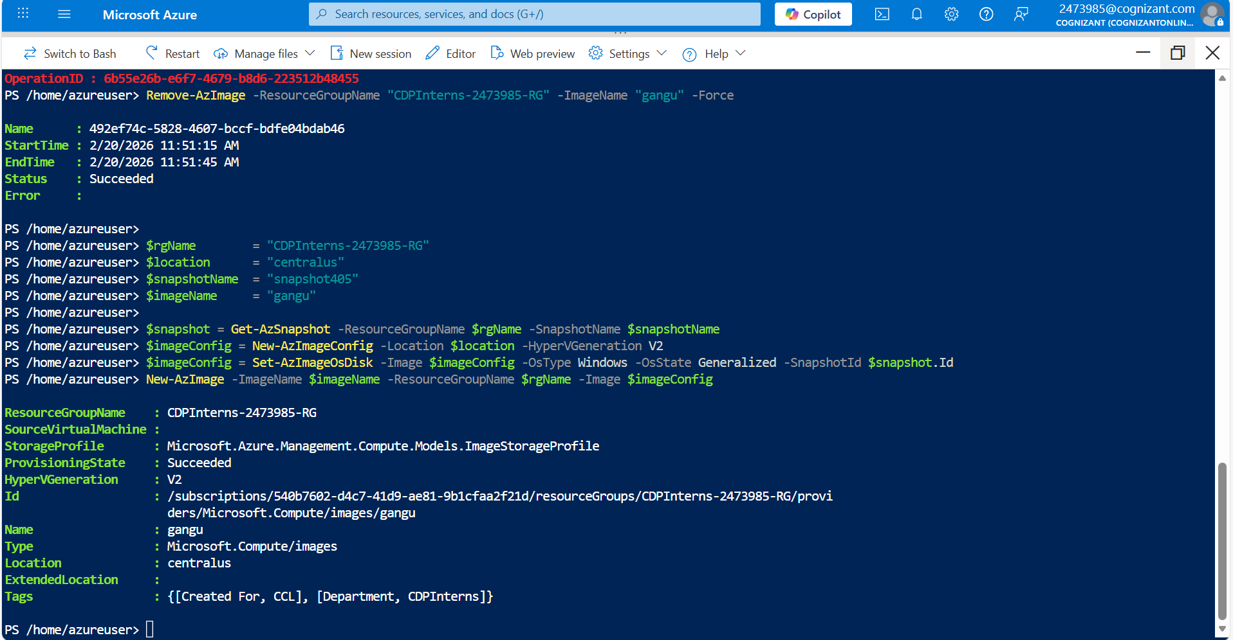

1 | Not able to create VM | Make sure you go through the error as the solution is most likely given there. Check region, VM size and other factors.
2 | Image is not created | Go through the error (if any). Check the commands are executed properly. Refer the link in the References Section to find the commands.

1.5 Supporting References
Refer the below link for additional information:

1. https://docs.microsoft.com/en-us/azure/virtual-machines/windows/capture-image-resource

